Aerografix Kits

Jacques Le Roux : https://www.facebook.com/sliceofthepast
Cell: 27824966177
E-Mail: jacquesleroux72.jlr@gmail.com
for orders

A Slice of history creations
Mamba Mk.1 1/35 Scale (AG35-13)  Resin Model Kit - Manufactured by Aerografix Models - THIS ITEM IS AVAILABLE ON PRE-ORDER  Our Price: R950.00 | 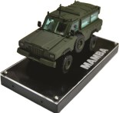

G6 H45 Gun 1/35 Scale (AG35-12)  Resin Model Kit - Manufactured by Aerographix Models - THIS ITEM IS AVAILABLE ON PRE-ORDER  Our Price: R1,025.00 | 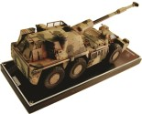
Olifant Mk.1a Tank SADF 1/35 Scale (AG35-10)  Resin Model Kit - Manufactured by Aerographix Models - THIS ITEM IS AVAILABLE ON PRE-ORDER  Our Price: R950.00 |  | 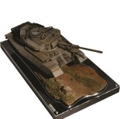
Badger 1/35 Scale (AG35-9)  Resin Model Kit - Manufactured by Aerographix Models - AVAILABLE ON PRE-ORDER  Our Price: R950.00 |  |  | 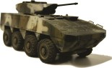
Long Tom Gun (Boer War) 1/35 Scale (AG35-8)  Resin Model Kit - Manufactured by Aerographix Models - THIS ITEM IS AVAILABLE ON PRE-ORDER  Our Price: R750.00 |  |  |  |  | 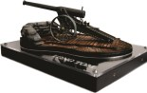
Ratel ZT3 1/35 Scale (AG35-7)  Resin Kit Manufactured by Aerographix Models - AVAILABLE ON PRE-ORDER  Our Price: R950.00 |  |  |  | 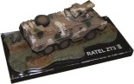
G5 155mm Howitzer 1/35 Scale (AG35-6)  Resin Model Kit manufactured by Aerografix Creative Models. AVAILABLE ON PRE-ORDER  Our Price: R950.00 |  |  |  |  |  | 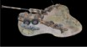

Eland 90 Armoured Car 1/35 Scale (AG35-5)  Resin Model Kit manufactured by Aerographix Creative Models. - AVAILABLE ON PRE-ORDER  Our Price: R750.00 |  | 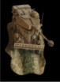
Rooikat with 76mm Gun 1/35 Scale (AG35-4)  Resin Model Kit manufactured by Aerographix Creative Models. - AVAILABLE ON PRE-ORDER  Our Price: R950.00 | 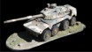

Rooikat with 105mm Gun 1/35 Scale (AG35-3)  Resin Model Kit manufactured by Aerographix Creative Models. - AVAILABLE ON PRE-ORDER  Our Price: R950.00 | 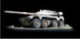

Ratel 90 1/35 Scale (AG35-2)  Resin Model Kit manufactured by Aerographix Creative Models. - AVAILABLE ON PRE-ORDER  Our Price: R950.00 | 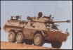

Ratel 20 1/35 Scale (AG35-1)  Resin Model Kit manufactured by Aerographix Creative Models - AVAILABLE ON PRE-ORDER  Our Price: R950.00 | 