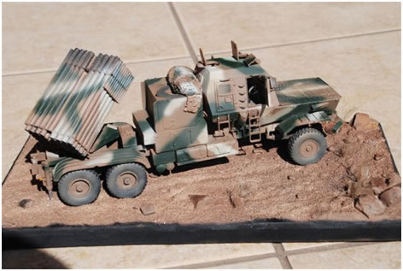

MRLS Bateleur
1/35th Scale – Resin & Photo Etch This a first class model of the Bateleur self-propelled rocket launcher. The system is a copy of the Soviet BM-21 Grad, examples of which were captured during Operation Savannah in Angola in 1976. Development was completed in 1981, and it was fielded in 1987 and 1988 by the South African Defence Force (SADF) in southern Angola against Cuban supported FAPLA forces, specifically during operations Hooper and Modular.
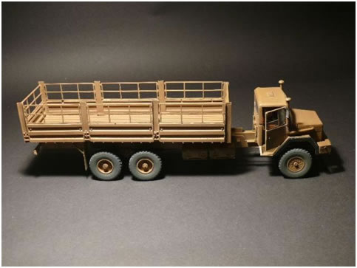

SAMIL 100 Load
1/35th Scale – resin & Photo Etch Standard 10 tonne category logistics vehicle. Produced in several variants including tanker, recovery and artillery tractor.

Buffel – Mine Protected Vehicle 1/35
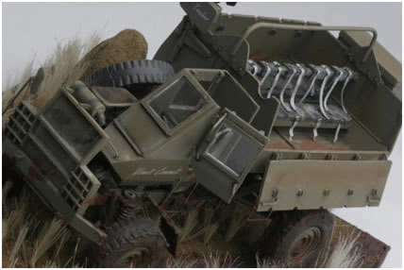
1/35th Scale - Resin & Photo Etch The Buffel is a mine-protected APC used by the South African Army during the South African Border War. The Buffel was also used as an armoured fighting vehicle and proved itself in this role. It has been replaced by the Mamba in South Africa, but remains in use elsewhere, notably Sri Lanka. This 1/35th scale kit builds into an impressive model that truly captures the look and feel of this iconic vehicle.

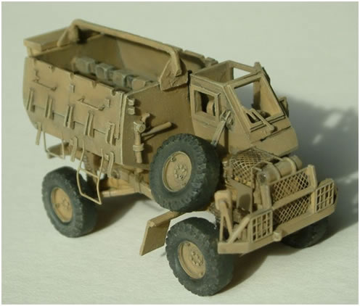

Buffel – Mine Protected Vehicle 1/72
1 72nd Scale - Resin & Photo Etch The Buffel is a mine-protected APC used by the South African Army during the South African Border War. The Buffel was also used as an armoured fighting vehicle and proved itself in this role. It has been replaced by the Mamba in South Africa, but remains in use elsewhere, notably Sri Lanka. This is an excellent kit with an incredible level of detail. The completed vehicle is excellent for wargaming.
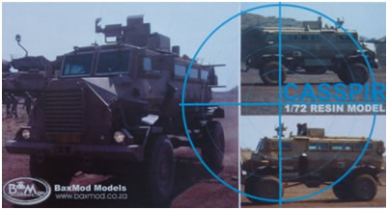

Casspir 1/72nd
1/72nd Scale - Resin and Photo Etch The Casspir is a landmine-protected personnel carrier that has been in use in South Africa for over 20 years. It is a four wheeled armoured vehicle, used for transport of troops. It can hold a crew of two, plus 12 additional soldiers and associated gear. The Casspir was unique in design when launched, providing for passive mine defence. This model captures the iconic lines of the Casspir perfectly.
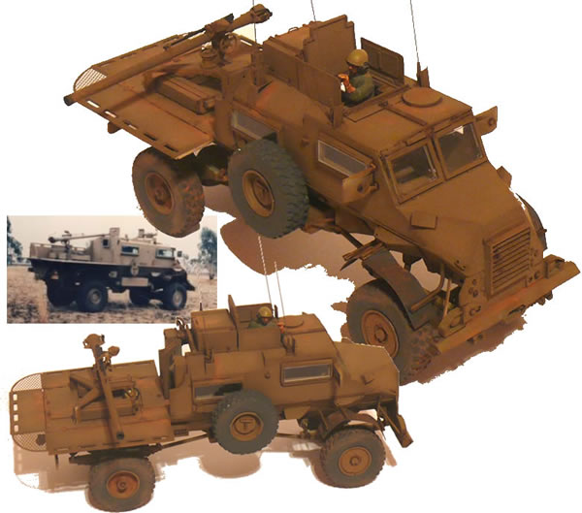

Casspir 106
1/35th scale – resin & Photo Etch The Casspir 106 is the latest model in the BaxMod range featuring a platform for the 106mm recoilless anti-tank gun. Designed to give anti-tank gunners a good field of fire, the Casspir 106 is an especially stable vehicle with an anti-landmine and armour protection capability. Photo etch parts and clear windows are supplied with the kit, which can be used in conjunction with the AFV, Military Wheels or Academy 106mm.

Ratel 20 Infantry Combat Vehicle

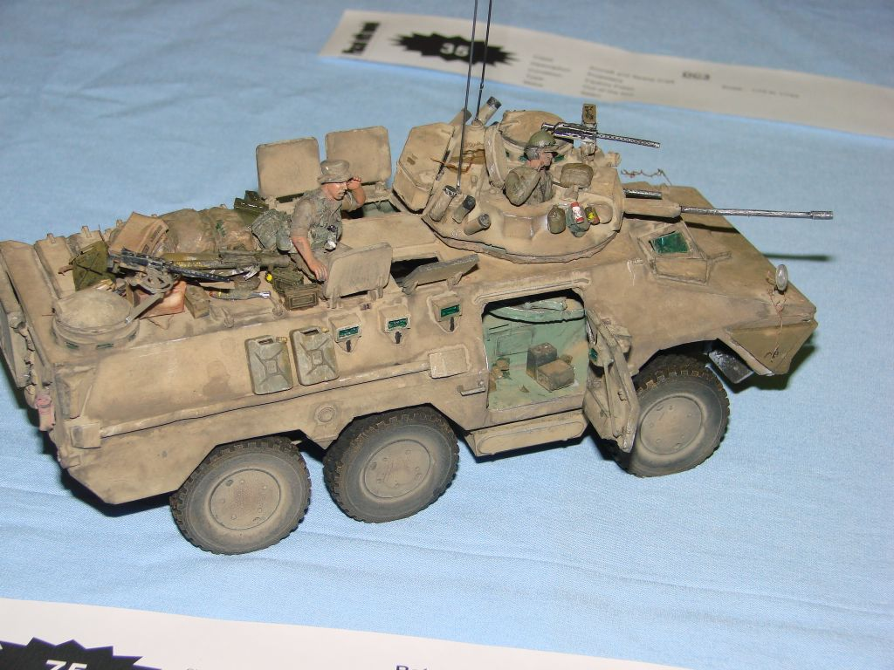
1/35th Scale – Resin & Photo Etch The basic ICV of the mechanised infantry battalions. Developed for the SA Army taking local conditions and requirements into account. Armour protection is given against small arms fire and shell fragments. The hull is designed to withstand mine-strikes. Probably the best ICV in the world and an impressive, imposing model. The BaxMod Ratel 20 is a classic.

Ratel Command

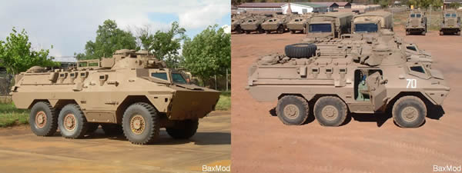
1/72nd Scale - Resin & Photo Etch The command vehicle variant of the Ratel ICV of the mechanised infantry battalions. Developed for the SA Army taking local conditions and requirements into account. Armour protection is given against small arms fire and shell fragments. The hull is designed to withstand mine-strikes.

Ratel ZT3

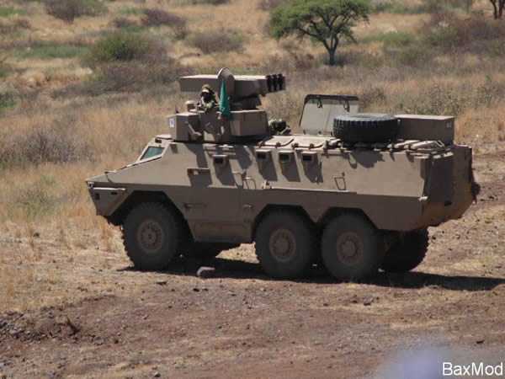
1/72nd Scale Resin & Photo Etch The anti-tank variant of the Ratel ICV carrying three ZT3 missiles along with spare missiles for the launcher. It replaced one Ratel 90 in each troop of the Armoured Car Squadrons to give the units an added long range Anti Tank capability. With the development of the ZT3 the South African Army finally has a potent Anti Tank missile capable of engaging modern MBTs, closing a dangerous gap in its inventory. As with the Ratel 81, the modifications has reduced the amount of passengers from 9 to 6. The hull is designed to withstand mine-strikes.

SAMIL 20

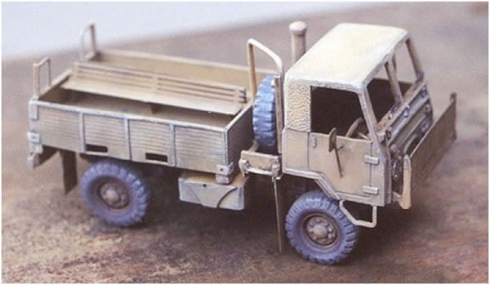
1/72nd Scale – Resin & Photo Etch SAMIL (South-African Military) is the name given to a series of trucks specially designed for the South African army. The SAMIL 20 was the utility vehicle workhorse of the Border War and could be found in various guises - troop carrier, water truck and even as a weapons platform for a 20mm AA or Milan AT system.

SAMIL 20 Mk 2

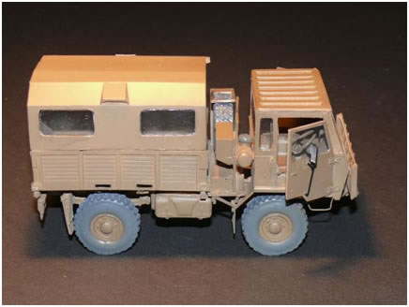
1/35th Scale – Resin & Photo Etch SAMIL (South-African Military) is the name given to a series of trucks specially designed for the South African army. The SAMIL 20 was the utility vehicle workhorse of the Border War and could be found in various guises - troop carrier, water truck and even as a weapons platform for a 20mm AA or Milan AT system.

SAMIL 20 Mk1

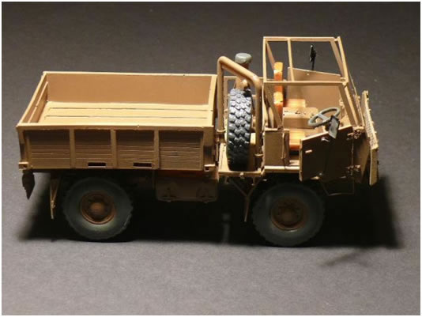
1/35th Scale - Resin & Photo Etch The SAMIL 20 4x4 is the ultimate, off-road vehicle. With the "diff locks" on the transfer box and both axles, a short wheelbase and a ground clearance of 460mm, the Samil 20 can go where other 4x4's fear to tread.

SAMIL 50 Load

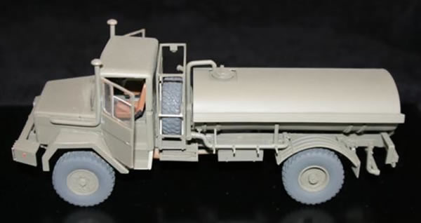
The Samil 50 4x4 is a genuine, off-road, workhorse. Capable of transporting a 5-ton payload almost anywhere. With "diff locks" on the transfer box on both axles.

SAMIL Kwe 100 Load

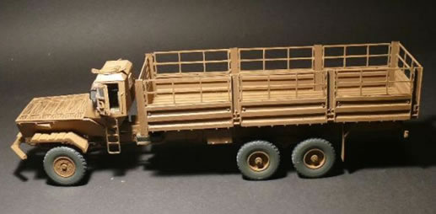
1/35th Scale – Resin & Photo Etch Produced as a flatbed, fuel and water bowser. This vehicle can also serve as a horse box.

